
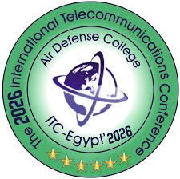


6th International Innovation Competition (ITC‑EGYPT 2026)

Graduation Project
Faculty/school: Thebes High Institute of Engineering.
University / Studying administration: Thebes High Institutes.

University Logo:

Project Title:
EyeTalk: AI-Based Head and Gaze Controlled Communication System for Motor-Impaired Patients
Supervisor:
Name | Email | WhatsApp number | position
Ahmed Abdul MaaroufJunaidi Azzam | Azzam4.aa@gmail.com | 01288586859 | Doctor

Team Members:
NO | Name | Email | WhatsApp  numbers
1 | Basel Mohamed Mostafa Said | baselmohamed802@gmail.com | 01033453452
2 | Ziad Refaie Abo Alftooh Refaie | ziadrar200@gmail.com | 01122029134
3 | Andrew Emad Sadek Mikhail | andrewemad761@gmail.com | 01220208563
4 | Hussin Hesham Ali Mohamed | hussinhisham79@gmail.com | 01229129583
5 | Mohamed Ahmed Abdel Nour Abdel Moneim | mohamed.abdalnour65@gmail.com | 01111003080

Executive Summary

1. Project Overview
EyeTalk is an AI-driven assistive communication system that enables individuals with severe motor impairments to control a computer and communicate using head orientation and gaze-based interaction. The system integrates computer vision, embedded processing, and speech synthesis to provide a hands-free human-computer interface.

2. Problem Statement
Millions of patients suffering from paralysis, neuromuscular diseases, spinal cord injuries, or stroke lose the ability to communicate independently. Existing assistive technologies are often expensive, invasive, or unavailable in developing regions. EyeTalk addresses the need for an affordable, non-invasive, and portable communication solution.

3. Practical Implementation
The system operates using a standard webcam and runs efficiently on embedded platforms such as Raspberry Pi. It uses optimized processing pipelines to ensure real-time performance, making it practical for hospitals, rehabilitation centers, and home care environments.

4. Partners and Funding
Currently, there are no official Partners or External Funding for our Project.

5. Contribution to Industry
EyeTalk contributes to the assistive technology and medical device industry by providing a low-cost AI-based communication framework. It bridges embedded systems engineering with intelligent human-computer interaction to provide a method for impaired people to talk again.

6. Industrial Potential
The system can be transformed into a semi-industrial or fully industrial product through proper cutting-edge hardware enclosure design, regulatory compliance certification, and more software optimization. It has strong commercialization potential as a portable assistive device.

7. Scientific Basis and Components
The project relies on computer vision theory, facial landmark detection models (MediaPipe FaceMesh), head pose estimation mathematics, Kalman filtering, other signal smoothing algorithms, and human-computer interaction principles.
Electronic Components:
- Raspberry Pi 5 8GB
- Webcam module (Off the shelf)
- Touchscreen display (10” display)
- Lithium battery power system (6000mAh)
Software Components:
- Python 3.12
- OpenCV
- MediaPipe
- PySide6 (GUI)
- Text-to-Speech engine

8. Target Beneficiaries
- Patients with motor disabilities
- Rehabilitation centers
- Hospitals and long-term care facilities
- Special needs education institutions

9. Startup Potential
EyeTalk can serve as the foundation for a startup focused on affordable assistive AI devices in emerging markets.
We already have strong Egyptian Language integration and Localization which can serve as strong foundation.

10. Financial Cost and Business Model
The prototype hardware cost is relatively low (approximately 17000 – 20000 EGP). A scalable business model may include direct device sales, institutional licensing, and future SaaS-based AI feature upgrades.

11. Future Work
Future development includes full eye-gaze tracking integration, machine learning personalization per patient/user, regulatory medical certification, and industrial-grade hardware packaging.

Team Structure and Responsibilities

Name | Contribution (%) and Description
Basel Mohamed Mostafa | Head Tracking and AI Model Pioneer, and 3D Design Creation [45%]
Ziad Refaie Abo Alftooh | GUI & Software Pioneer [20%]
Andrew Emad Sadek | GUI Localization and Improvement [10%]
Hussin Hesham Ali | Eye Gaze AI Model Assist [15%]
Mohamed Ahmed Abdulnoor AbdulMoneim | 3D Design Planning & Documentation [10%]

Partners and financiers.
Currently, there are no official Partners or External Funding for our Project.

Abstract
EyeTalk is an AI-based assistive communication system developed to support individuals with severe motor impairments who are unable to use conventional input devices. The system enables hands-free interaction through head orientation and gaze-based control, allowing users to operate a computer and communicate effectively.
Using standard camera and computer vision techniques, facial landmarks are detected via Mediapipe Face Mesh. Head orientation vectors are computed and mapped to screen coordinates through a configurable control core supporting both absolute and relative cursor modes. To ensure smooth and stable operation, the system integrates Kalman filtering and Exponential Moving Average (EMA) smoothing. A calibration module enhances accuracy by statistically aligning the system to each user’s neutral head position.
EyeTalk includes a bilingual (Arabic/English) virtual keyboard interface with integrated Text-to-Speech functionality, enabling real-time spoken communication. Predefined emergency phrases allow rapid expression of urgent medical needs. The system is designed for low-cost deployment on embedded platforms such as Raspberry Pi, making it portable and accessible.
By combining artificial intelligence, computer vision, and assistive interface design, EyeTalk provides an affordable and scalable solution to improve independence and quality of life for motor-impaired individuals.

Abbreviations and Terms
Abbreviation | Definition
Assistive Technology | Technology designed to enhance functional capabilities and independence for individuals with disabilities.
Human-Computer Interaction (HIC) | The study and design of systems that enable effective interaction between humans and computers.
Head Tracking | A computer vision technique that estimates head position and orientation to control digital interfaces.
Gaze Interaction | A method of user input where eye gaze direction is used to select or control on-screen elements.
Computer Vision | A field of artificial intelligence that enables machines to interpret and analyze visual information from images or video.
Kalman Filter | A recursive mathematical algorithm used to estimate and smooth noisy measurements in dynamic systems.
Embedded Systems | Dedicated computing systems are integrated within hardware to perform specific real-time tasks.
Virtual Keyboard | A software-based keyboard interface that allows text input without a physical keyboard.
Text-to-Speech (TTS) | A speech synthesis technology that converts written text into audible spoken output.
Medical Assistive Systems | Technological systems are designed to support diagnosis, rehabilitation, or daily living for patients with medical conditions.

Introduction
Loss of motor control due to paralysis, neuromuscular disorders, spinal cord injuries, or stroke severely limits a patient’s ability to communicate and interact with digital systems. For many individuals, even basic actions such as typing, calling for assistance, or expressing urgent needs become impossible without external help. This communication barrier directly impacts independence, psychological well-being, and quality of life.
Although assistive communication technologies exist, many solutions are either prohibitively expensive, require specialized hardware, depend on invasive sensors, or demand complex calibration procedures. High-end eye-tracking systems remain inaccessible in many developing regions due to cost and infrastructure limitations. As a result, there is a significant gap between advanced research prototypes and affordable, deployable assistive systems.
EyeTalk addresses this gap by providing a low-cost, non-invasive, AI-based communication platform that runs on accessible embedded hardware such as the Raspberry Pi. The system uses computer vision techniques to extract facial landmarks through MediaPipe FaceMesh and compute head orientation vectors for cursor control. Advanced filtering techniques, including Kalman filtering and exponential smoothing, ensure stable and precise interaction. A bilingual (Arabic/English) virtual keyboard with integrated Text-to-Speech functionality enables real-time verbal communication, including predefined emergency phrases.
The overall goal of EyeTalk is to create a scalable, portable, and practical assistive communication device that bridges artificial intelligence, embedded systems, and human-computer interaction, transforming advanced vision algorithms into an affordable real-world medical solution.

Novelty
EyeTalk introduces a distinctive approach to assistive communication by combining affordability, embedded deployment, bilingual accessibility, and adaptive control architecture within a single unified system.
Unlike many commercial eye-tracking solutions that rely on expensive infrared hardware, proprietary cameras, or specialized sensors, EyeTalk operates using a standard webcam and optimized computer vision algorithms. This significantly reduces hardware costs while maintaining real-time performance through efficient filtering and control mechanisms. The system is specifically engineered to run on embedded platforms such as Raspberry Pi, making it portable and deployable in low-resource environments.
A key innovation lies in hybrid control architecture. EyeTalk supports both head-orientation-based control (already implemented) and planned AI-based gaze estimation integration using deep learning models. The modular control core allows switching between absolute and relative cursor modes, improving adaptability across users with different motor capabilities.
Additionally, the system incorporates statistical calibration, Kalman filtering, and exponential smoothing to enhance precision and reduce jitter—addressing a common limitation in vision-based assistive interfaces.
Another distinctive feature is its bilingual (Arabic/English) communication interface with integrated Text-to-Speech and predefined emergency expressions, making it regionally adaptable and immediately usable in clinical environments.
This combination of low-cost hardware, embedded AI deployment, adaptive control architecture, and localization makes EyeTalk a practical, scalable, and socially impactful innovation in the assistive technology field.

Methodology

1. System Architecture
EyeTalk follows a modular real-time processing pipeline consisting of five core stages:
1.1. Image Acquisition:
A standard RGB camera captures live frames at controlled intervals to maintain stable FPS on embedded hardware.
2. Vision Processing:
MediaPipe FaceMesh extracts facial landmarks. Head orientation (yaw and pitch) is computed using geometric relationships between key facial reference points.
3. Signal Filtering:
To ensure stability and reduce noise:
- Kalman filtering is applied for dynamic estimation.
- Exponential Moving Average (EMA) smoothing reduces jitter.
- Sensitivity thresholds prevent unintended cursor drift.
4. Control Mapping:
Head pose values are mapped to screen coordinates using:
- Absolute mapping (direct screen positioning)
- Relative mapping (velocity-based cursor movement)
A calibration module defines a neutral reference pose for each user.
5. Application Layer:
A PySide6-based bilingual GUI integrates:
- Virtual keyboard (Arabic/English)
- Predefined emergency phrases
- Text-to-Speech output

2. Technologies Used
Hardware:
- Raspberry Pi
- RGB Camera
- Touchscreen Display
- Lithium Battery System
Software:
- Python
- OpenCV
- MediaPipe
- PySide6
- Text-to-Speech Engine
- Kalman Filter & EMA smoothing

3. Special Cases Handling
- Cursor freeze during face-loss detection
- Confidence threshold control in low light
- Noise suppression for micro-movements
- User-specific calibration normalization

4. Error Analysis
Sources of Error:
- Landmark detection inaccuracies
- Calibration bias
- Processing latency
Mitigation & Fixes:
- Filtering algorithms (Kalman + EMA)
- Adjustable sensitivity parameters
- Frame-rate optimization for embedded deployment

Results

Software Showcase
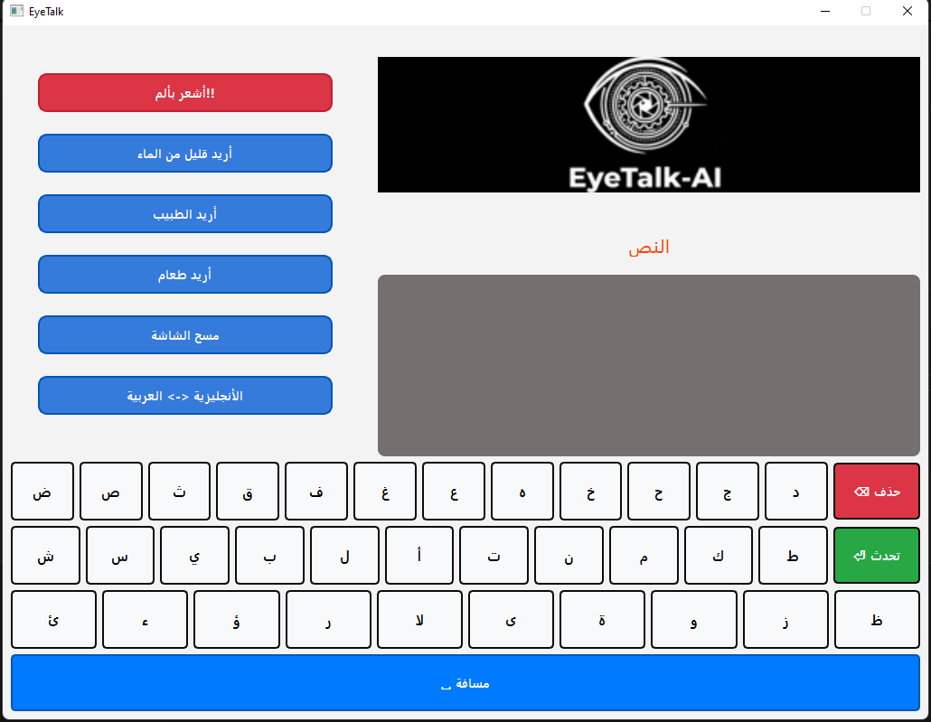
The following Two pictures demonstrate our GUI Keyboard program specifically tailored for our System featuring both full English and Arabic.
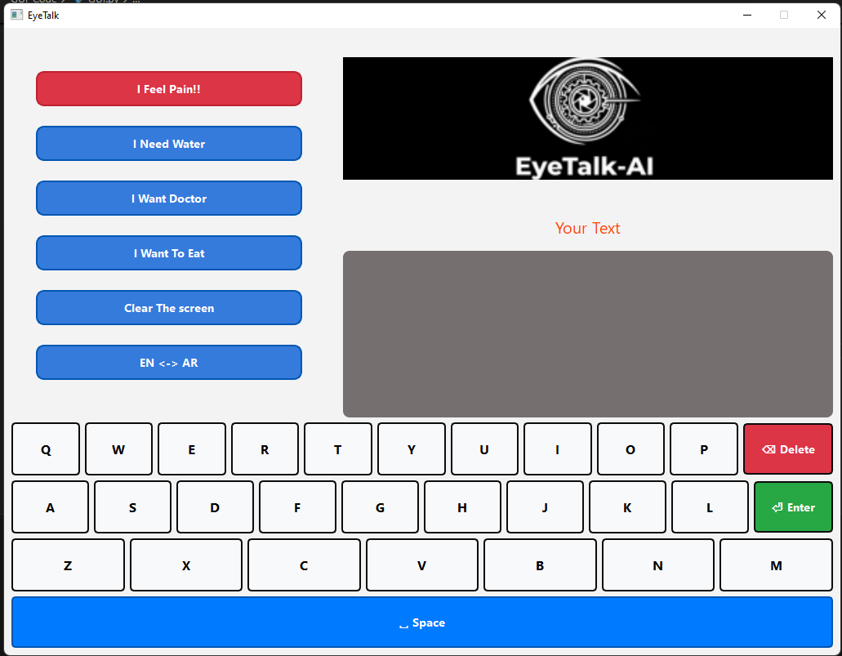

The following Pictures demonstrate our fully working Head Tracking AI Model that controls the mouse cursor via the user moving his head, built using Mediapipe FaceMesh:
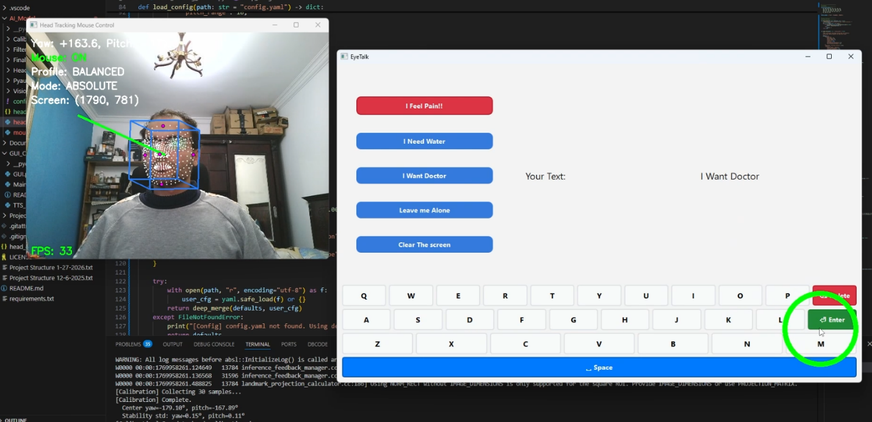
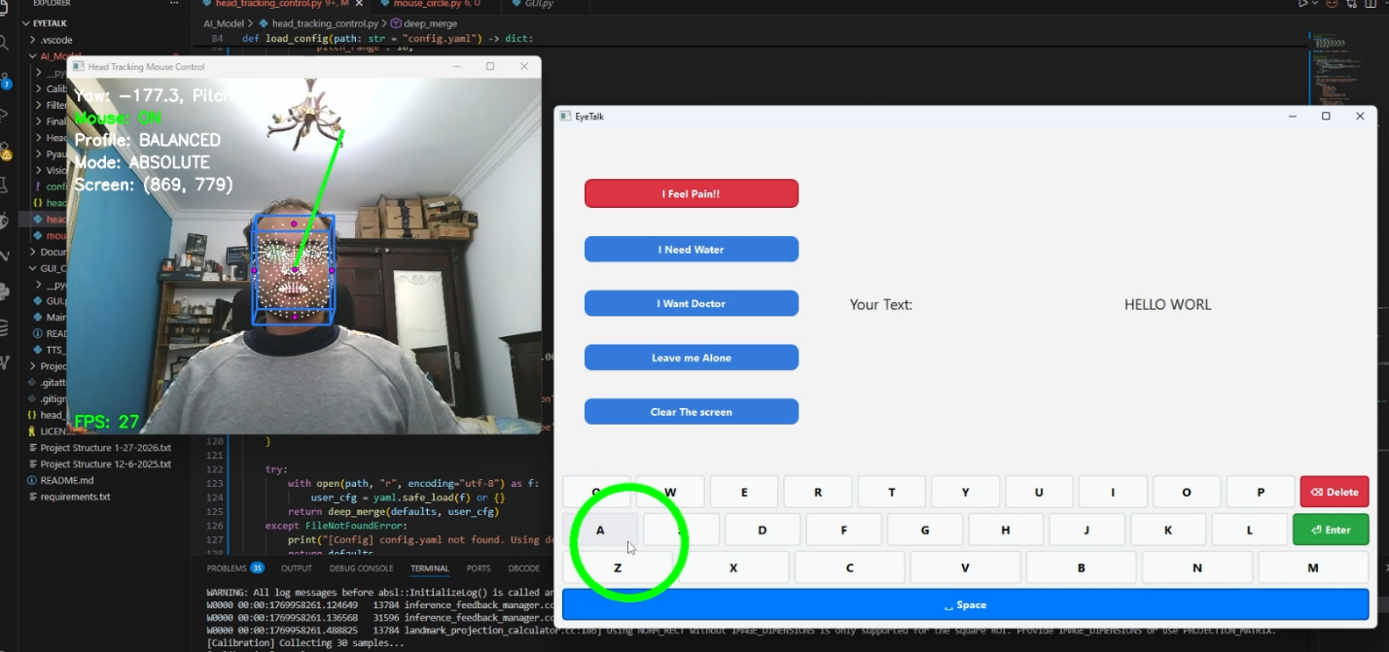

Hardware & 3D Design Showcase
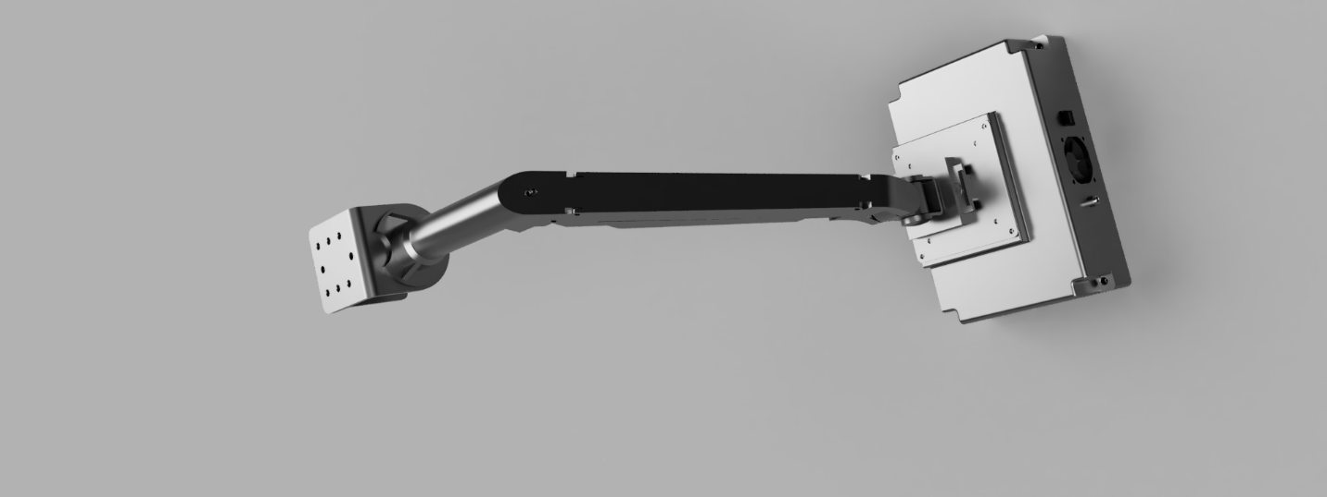

The following pictures demonstrates how we envision EyeTalk to be; A system that is fully portable and usable no matter where the patient is and can easily be used anywhere and mountable with a VESA standard Mount.
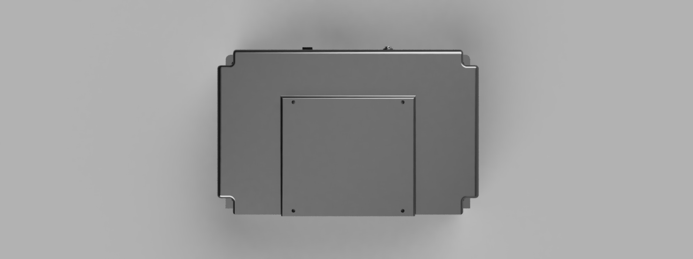
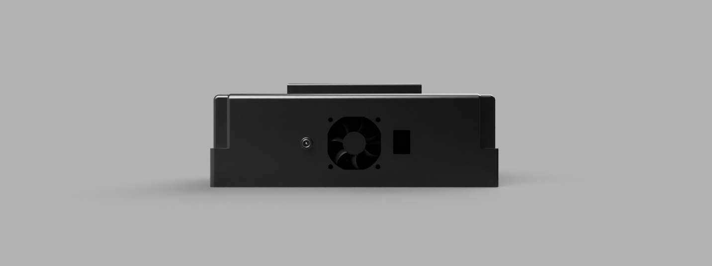
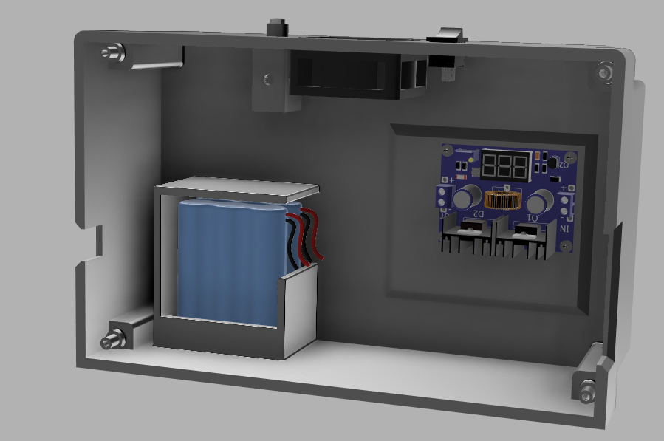


Product

1. Product Purpose
EyeTalk is a portable AI-based assistive communication device that enables individuals with severe motor impairments to control a computer and communicate using head movement and gaze interaction.
Its core value lies in providing low-cost, non-invasive, real-time communication without specialized hardware.

2. Core Features & Functionality
- Real-time head tracking (yaw/pitch estimation)
- Dual cursor control modes (absolute & relative)
- Bilingual virtual keyboard (Arabic / English)
- Integrated Text-to-Speech output
- Predefined emergency phrases
- Calibration module for user adaptation
- Embedded deployment (Raspberry Pi)
- Modular architecture ready for gaze tracking integration

3. Applicability
EyeTalk can be deployed in:
- Hospitals
- Rehabilitation centers
- Home care environments
- Special education institutions
- Long-term care facilities

4. Components Used
Electronic Components:
- Raspberry Pi 5
- RGB Camera Module
- 10” Touchscreen Display
- Lithium Battery System
- Power Management Circuit

Physical Components:
- Portable enclosure (3D printed / molded casing)
- Adjustable camera mount
- Battery housing system
Software Components:
- Python
- OpenCV
- MediaPipe FaceMesh
- PySide6 GUI Framework
- Text-to-Speech Engine
- Kalman Filter + EMA smoothing
- Custom control & calibration modules

5. Prototype Cost
Current prototype cost (approximate):
- Raspberry Pi 5: 7000
- Display: 5600
- Camera: 1500
- Battery + Accessories: 3000
Estimated Prototype Total: 17100~ EGP

6. Expected Product Cost (Mass Production)
With bulk manufacturing and custom PCB integration:
Estimated Unit Cost: 12000-14000 EGP

7. Market Size
According to the World Health Organization, over 2.5 billion people worldwide require at least one assistive technology product.
The global assistive technology market is projected to exceed $30+ billion, with strong growth in emerging markets.
Target segment:
- Patients with paralysis
- ALS, stroke, spinal cord injuries
- Severe motor disabilities

8. Expected Customers / Early Interest
Primary customers:
- Hospitals & rehabilitation centers
- NGOs supporting people with disabilities
- Families of motor-impaired patients
Early customer interest is expected from regional rehabilitation centers due to:
- Arabic language support
- Lower price compared to imported eye trackers

9. Business Model Canvas (Summary)
Value Proposition:
Affordable, portable AI-based communication device.
Customer Segments:
Hospitals, rehabilitation centers, NGOs, home-care patients.
Channels:
Medical suppliers, direct sales, partnerships with clinics.
Revenue Streams:
- Device sales
- Institutional licensing
- Software upgrades
- Maintenance & support packages
Key Resources:
AI software, embedded hardware design, clinical partnerships.
Key Activities:
Manufacturing, software updates, regulatory compliance.
Key Partners:
Medical institutions, assistive device distributors, NGOs.
Cost Structure:
Hardware production, software development, marketing, certification.

10. Top 3 Competitors
- Tobii Dynavox Eye Tracker
High-precision eye tracking, but very expensive.
- EyeTech Digital Systems
Medical-grade eye tracking systems.
- Irisbond
Non-invasive eye tracking communication devices.
Differentiation:
EyeTalk focuses on affordability, embedded portability, and regional accessibility.

11. Pricing Strategy
Target retail price: 14000 EGP, Positioned significantly below high-end systems (30000 - 50000 range)
- Institutional bulk discount model
- Potential tiered pricing for software upgrades

12. Risk Assessment & Mitigation
Risk | Mitigation Strategy
Tracking instability | Advanced filtering & calibration
Regulatory barriers | Gradual medical certification process
Competition from established brands | Focus on affordability & localization
Hardware cost fluctuation | Bulk purchasing & custom PCB integration

References
[1] Raspberry Pi Foundation, “Raspberry Pi Documentation.”
Available: https://www.raspberrypi.com/documentation/
[2] MediaPipe Documentation, “Face Mesh Solution,” Google Developers.
Available: https://developers.google.com/mediapipe/solutions/vision/face_mesh
[3] World Health Organization (WHO), “Assistive Technology.”
Available: https://www.who.int/news-room/fact-sheets/detail/assistive-technology
[4] Kalman Filter Introduction
Available: https://www.geeksforgeeks.org/python/kalman-filter-in-python/

